Q1 solutions

1 BC

2 ACD

3 ACD

4 AB

5 E

6 A

7 C

8 BD

9 E

10 ACD

11 AC

12 ABCD

13 ACD

14 ABC

15 A

2

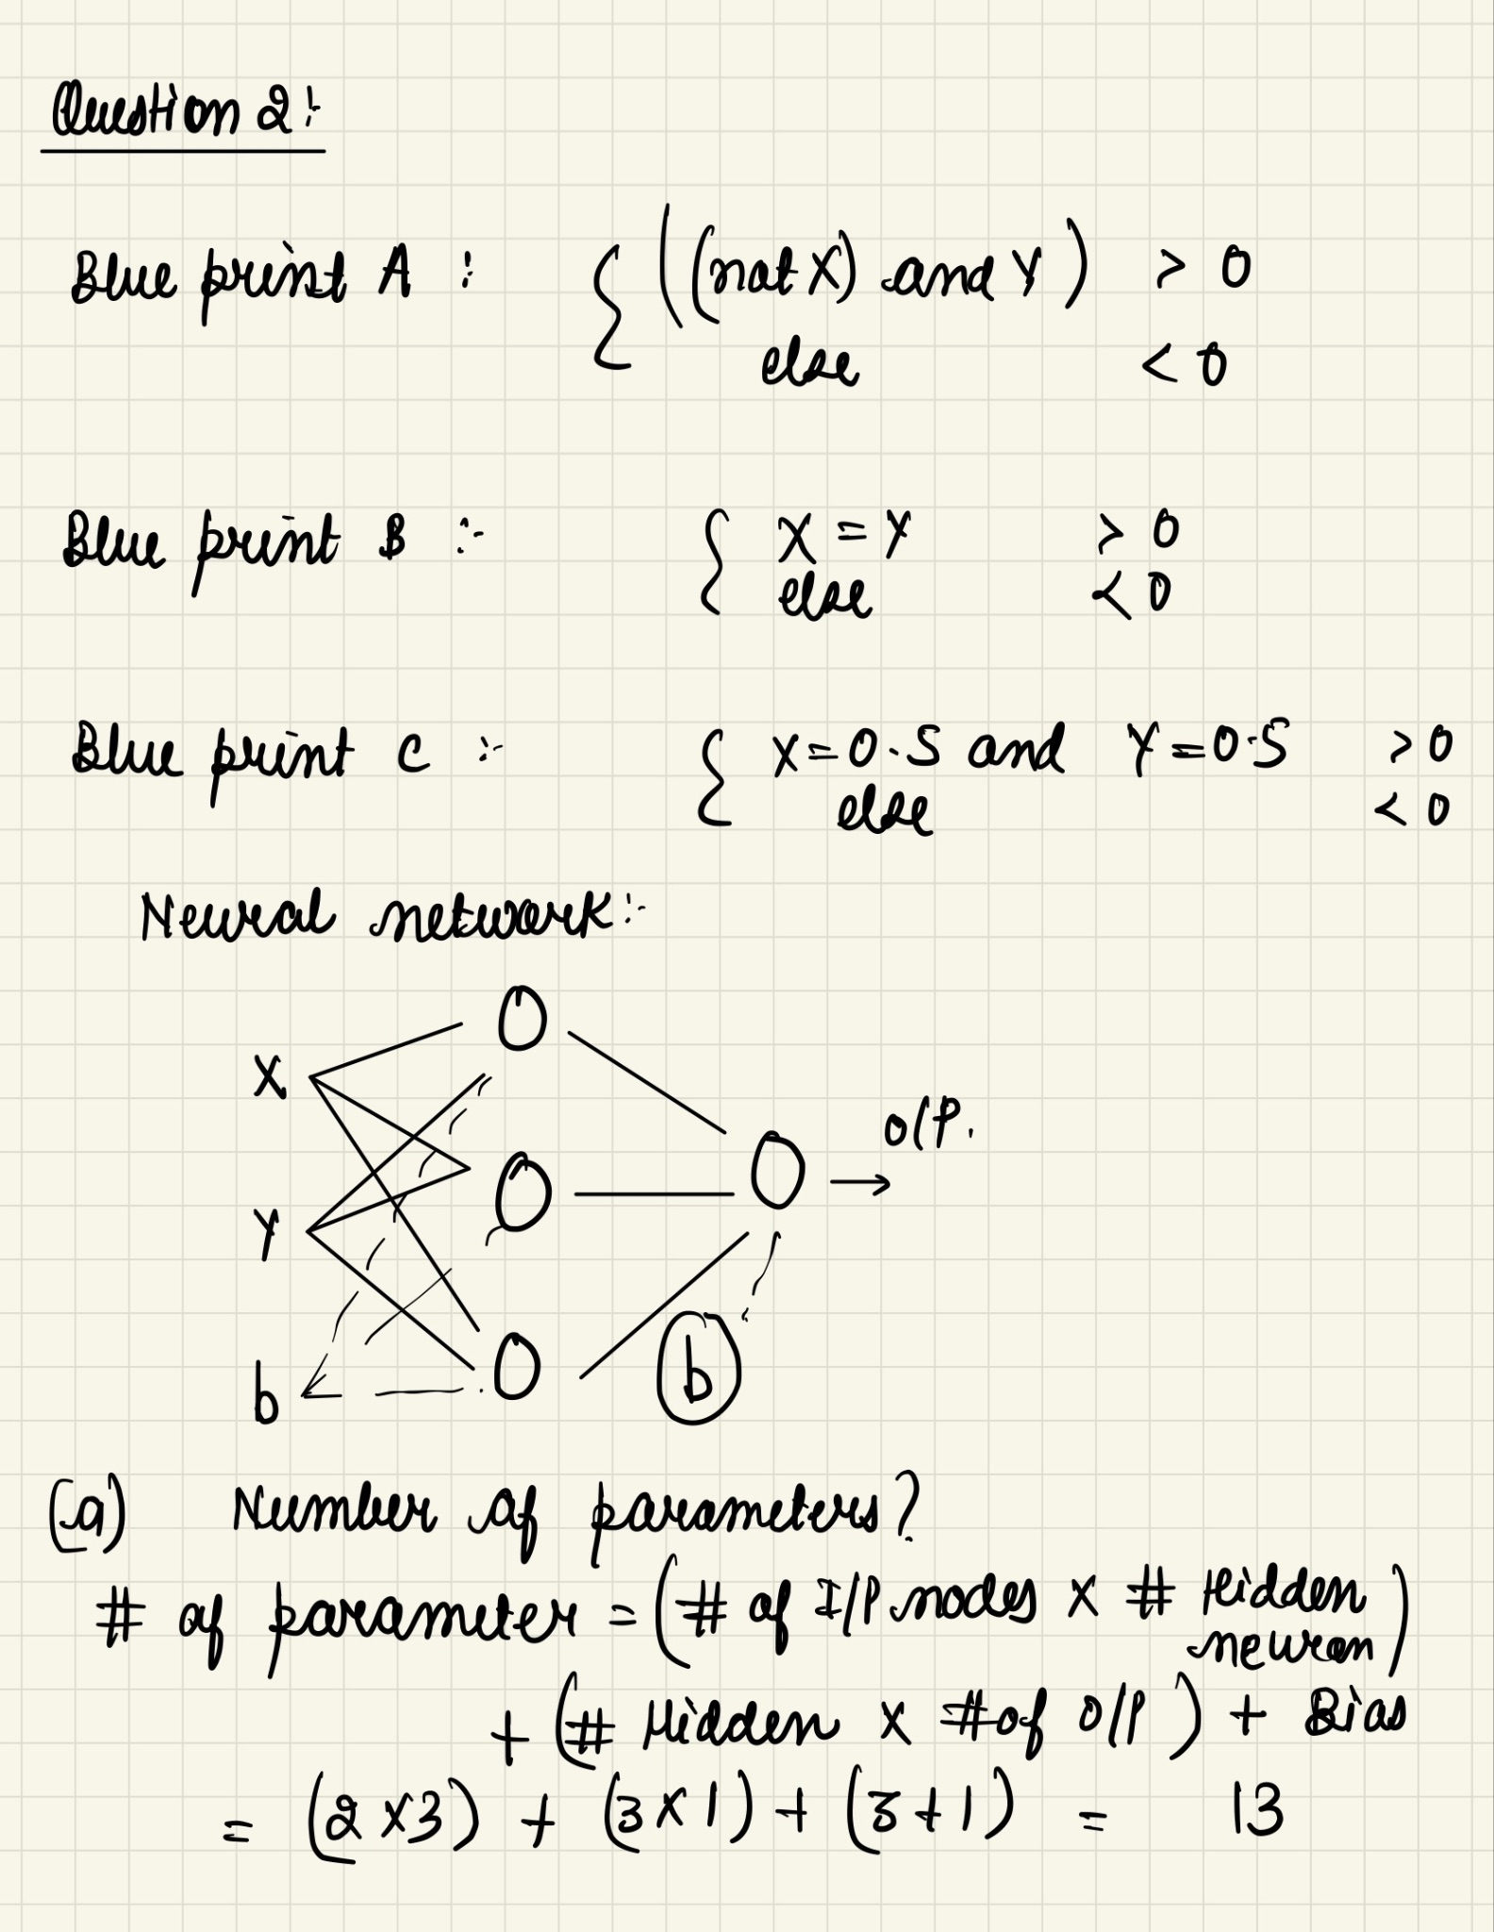

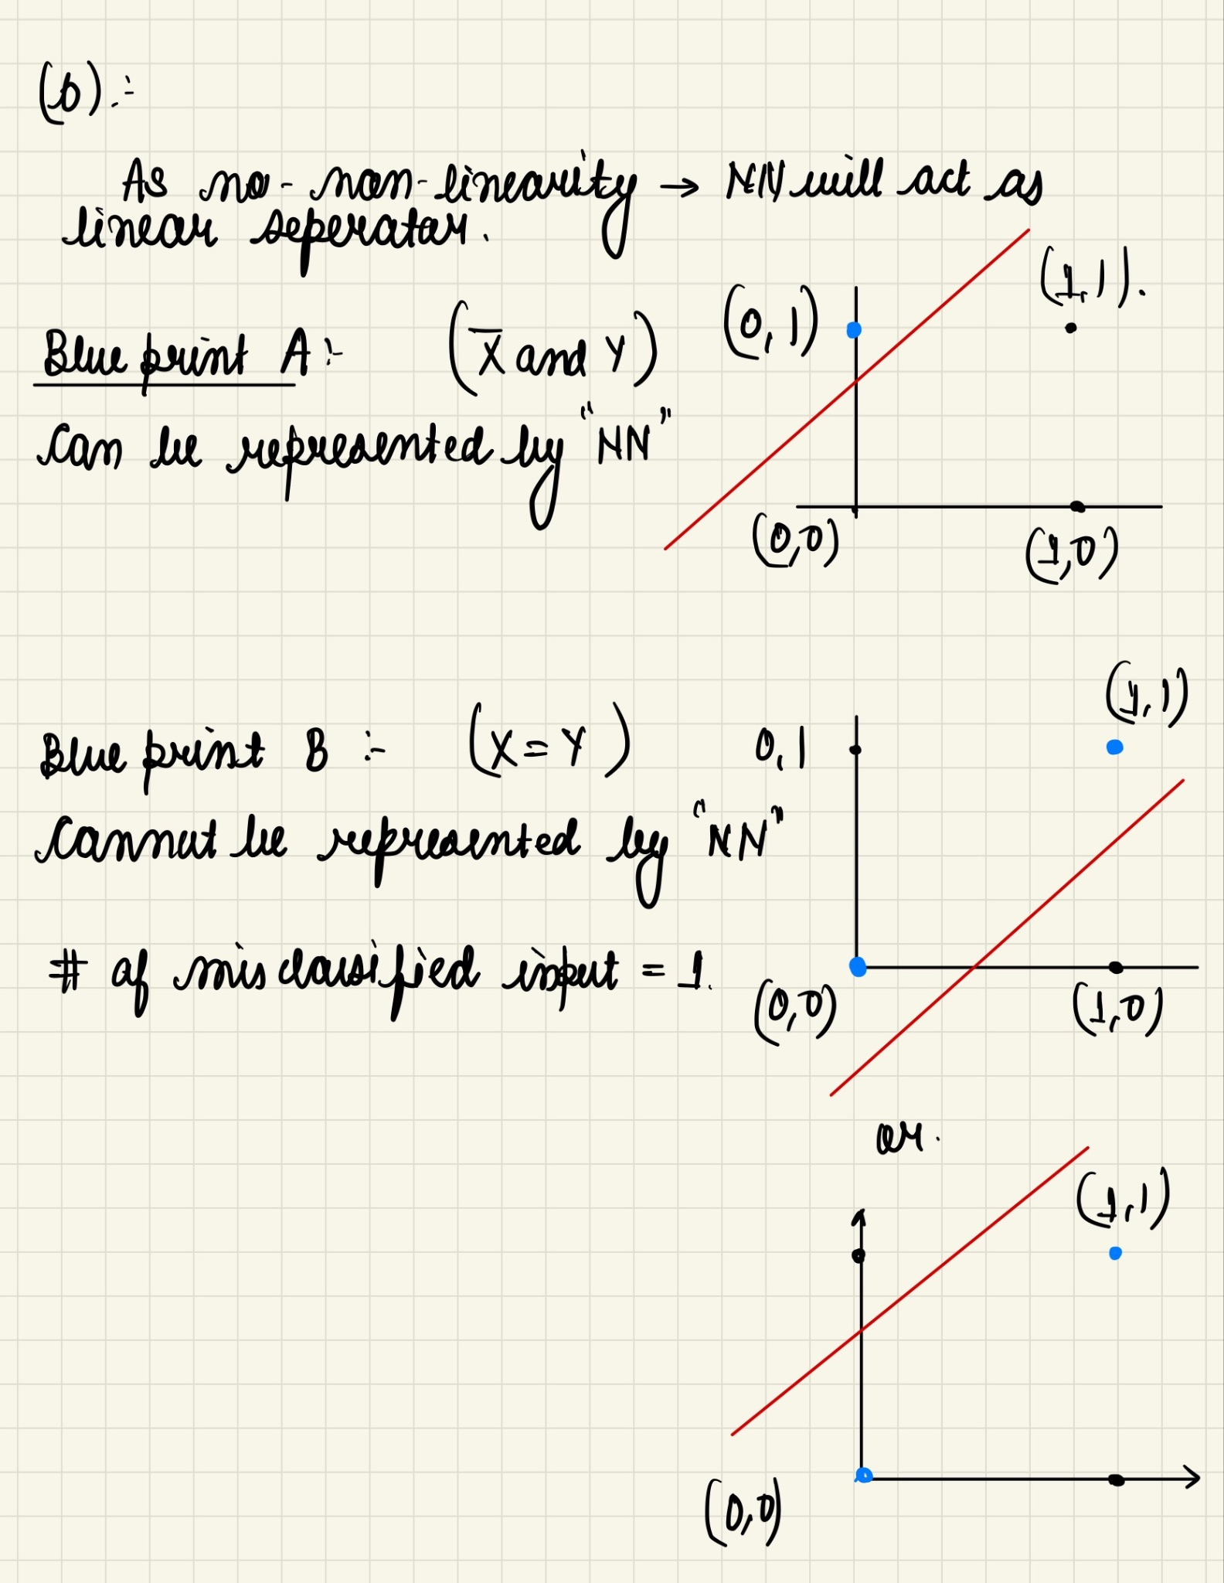

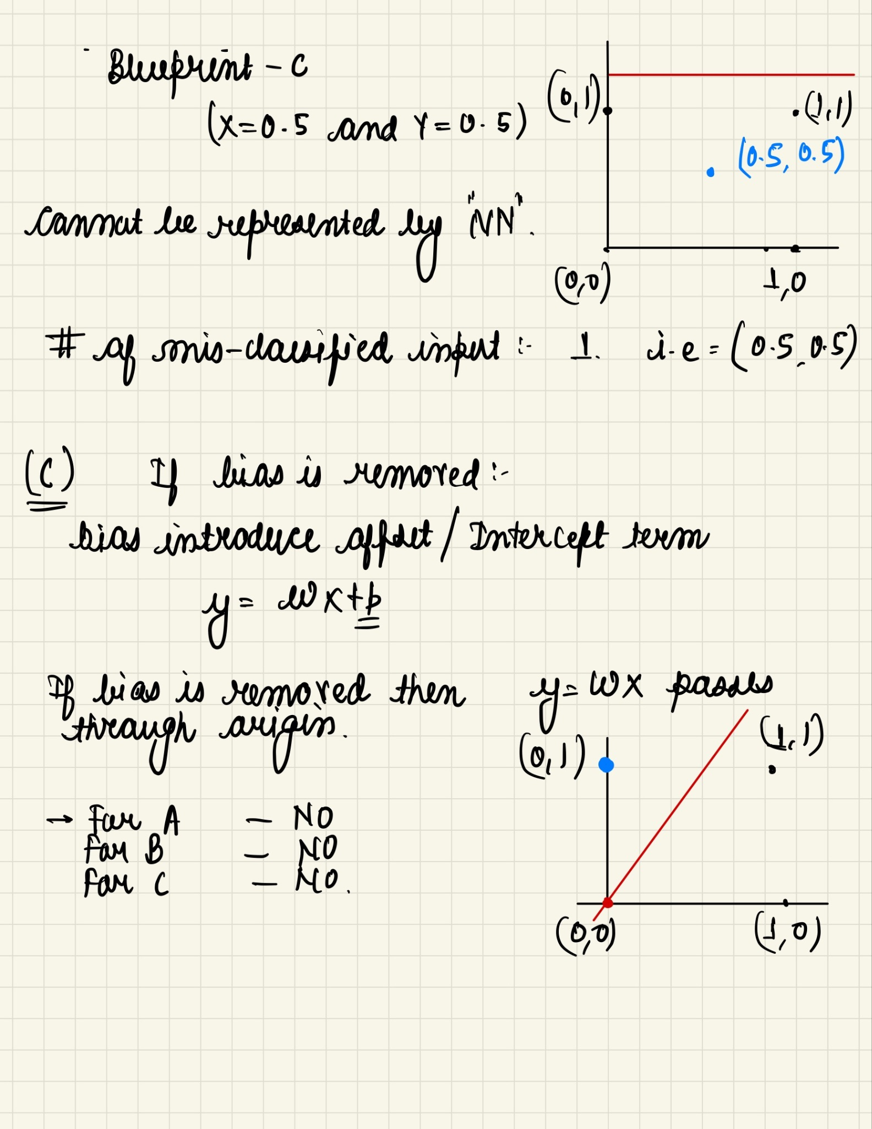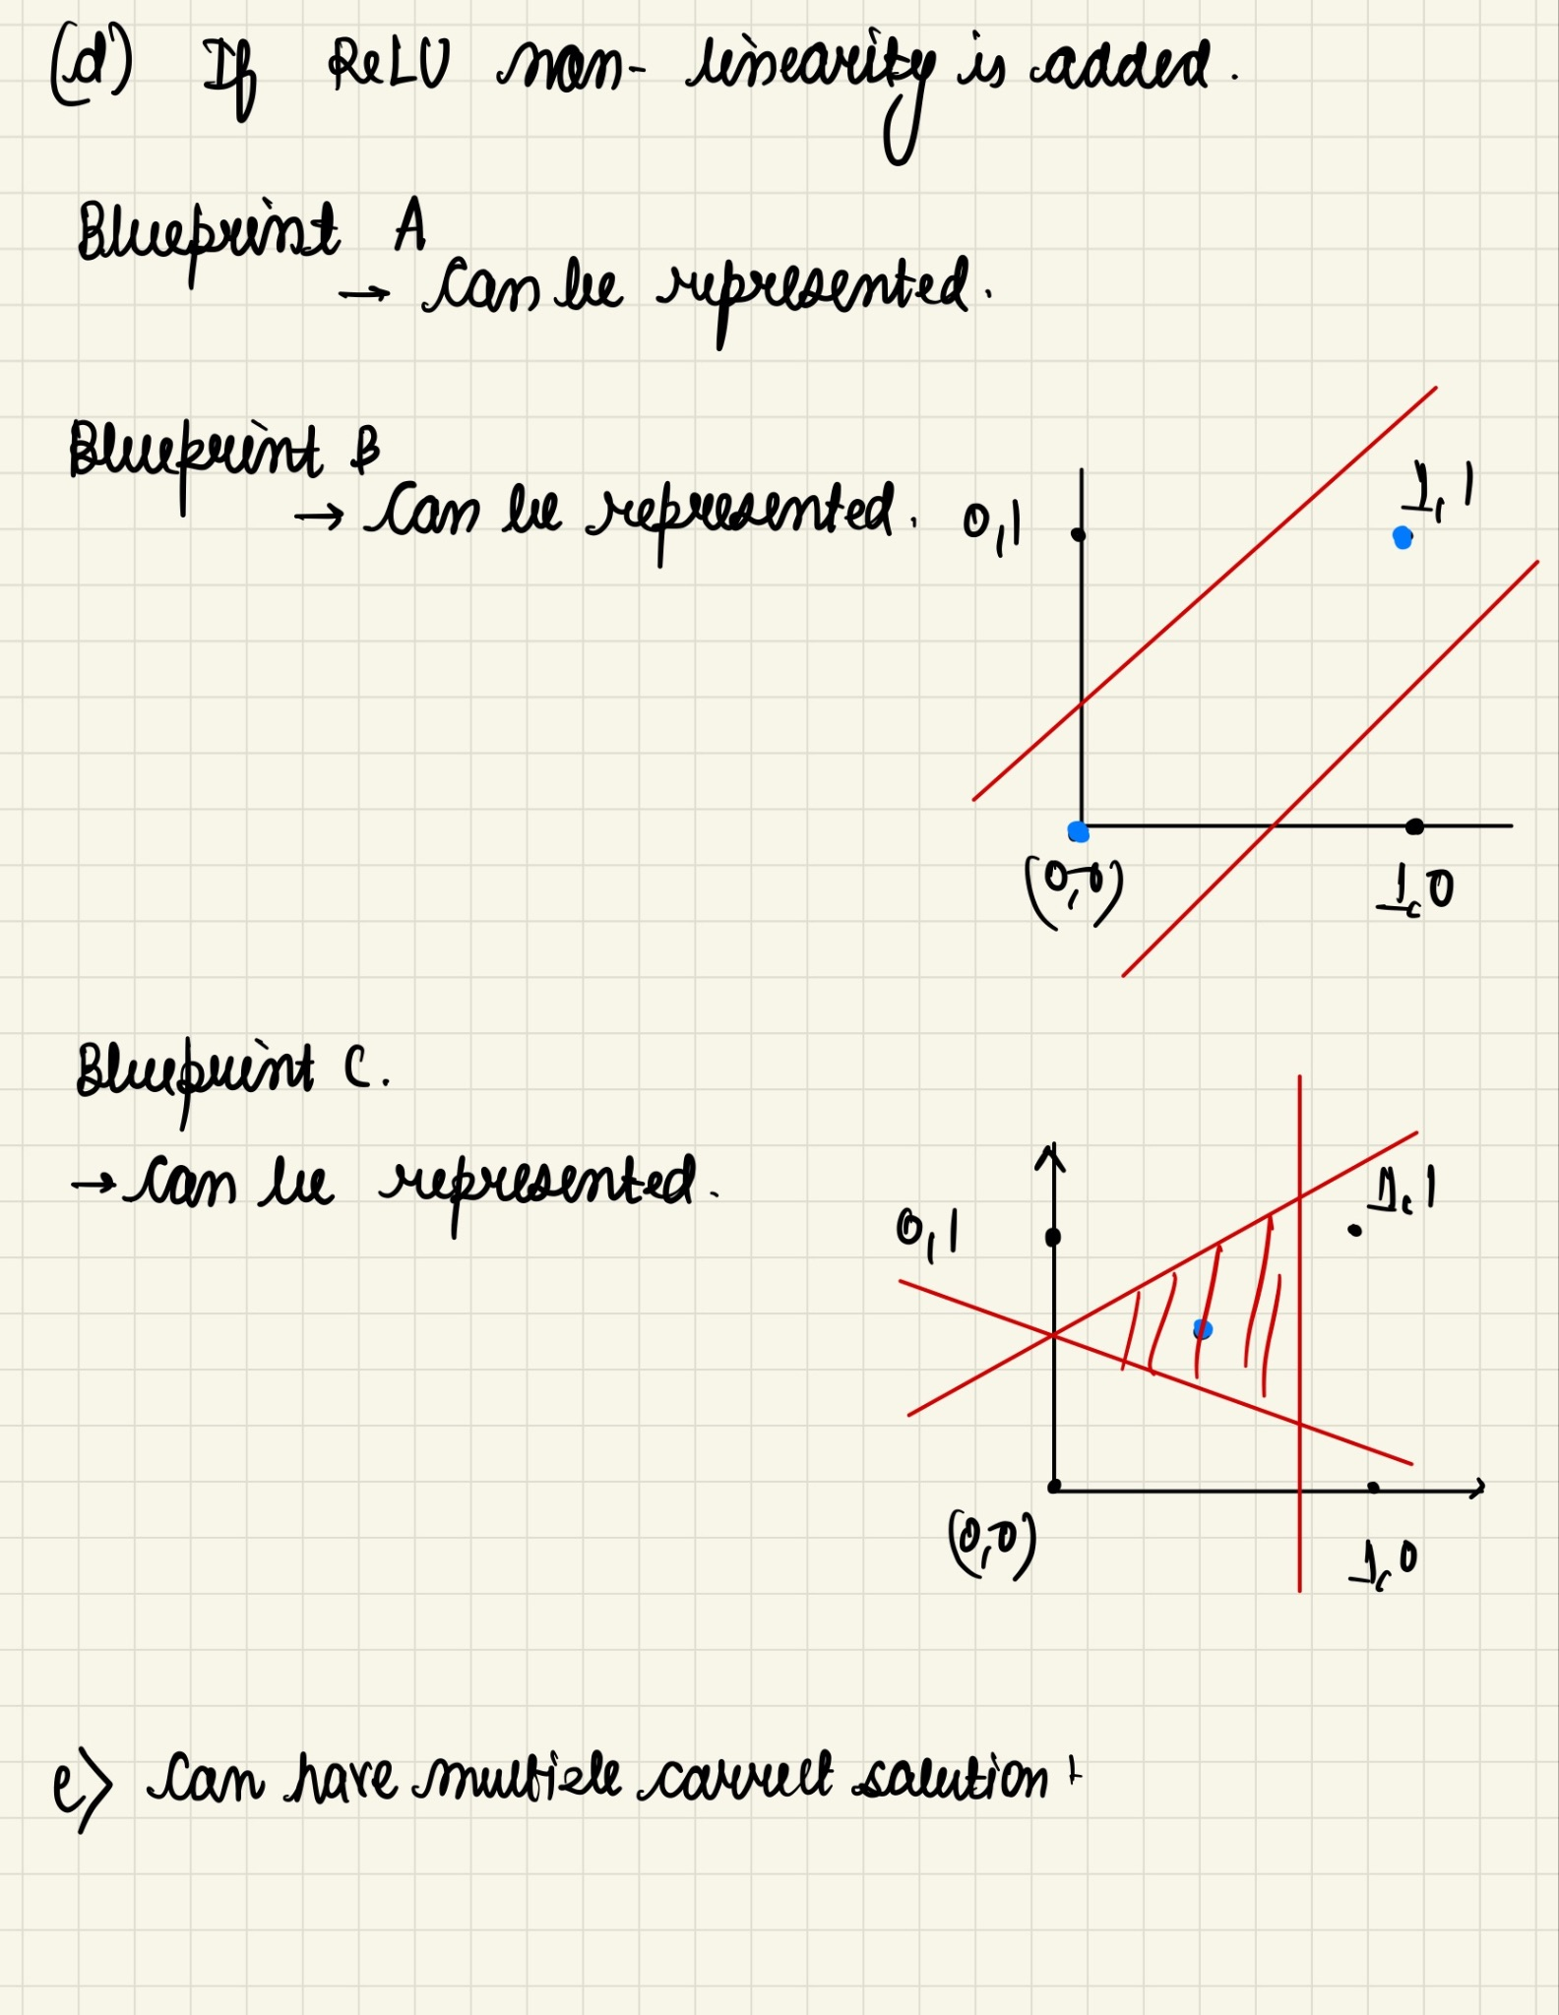

**Grading rubric for 2**

1. Correct number of parameters: 13 (1 Marks)
2. Correct representation of blueprint identification.

Blueprint A - 1 Mark

Blueprint B - 1 Mark

Blueprint C- 1 Mark

Correct misclassifier input identification B - 1 Mark

Correct misclassifier input identification C - 1 Mark

1. Identifying Blueprint A not able to represent - 1 Mark
2. Identifying representability of

Blueprint A - 1 marks

Blueprint B - 1 marks

Blueprint C - 1 marks

1. Correct weights - 2 Marks

Logic/ intuition : Partial mask - 1 Mark

3) Rubric:

S: adding a_i’s: 1, current time: 1 (no marks cut for defining extra states like sum <= T) ..

(solution should make it explicit that they’re tracking time, and won’t play after T)

T: 1 mark for defining it correctly between successor states, 1 mark for defining it as 0 for non successors, 1 mark for handling the last state at T

R: 1 mark for successor, 1 mark for non-successor, 1 mark for handling the last state at T

S0: 1

(b) Equation: 2 marks,

Simplifying V – 2 marks

Observation that V depends only on t – 2 marks

Answer – 2 marks

Note that marks have also been given for alternate formulations. State space must have cardinality >= T^K to be a correct solution. State spaces which only record the number of the last face are incorrect.

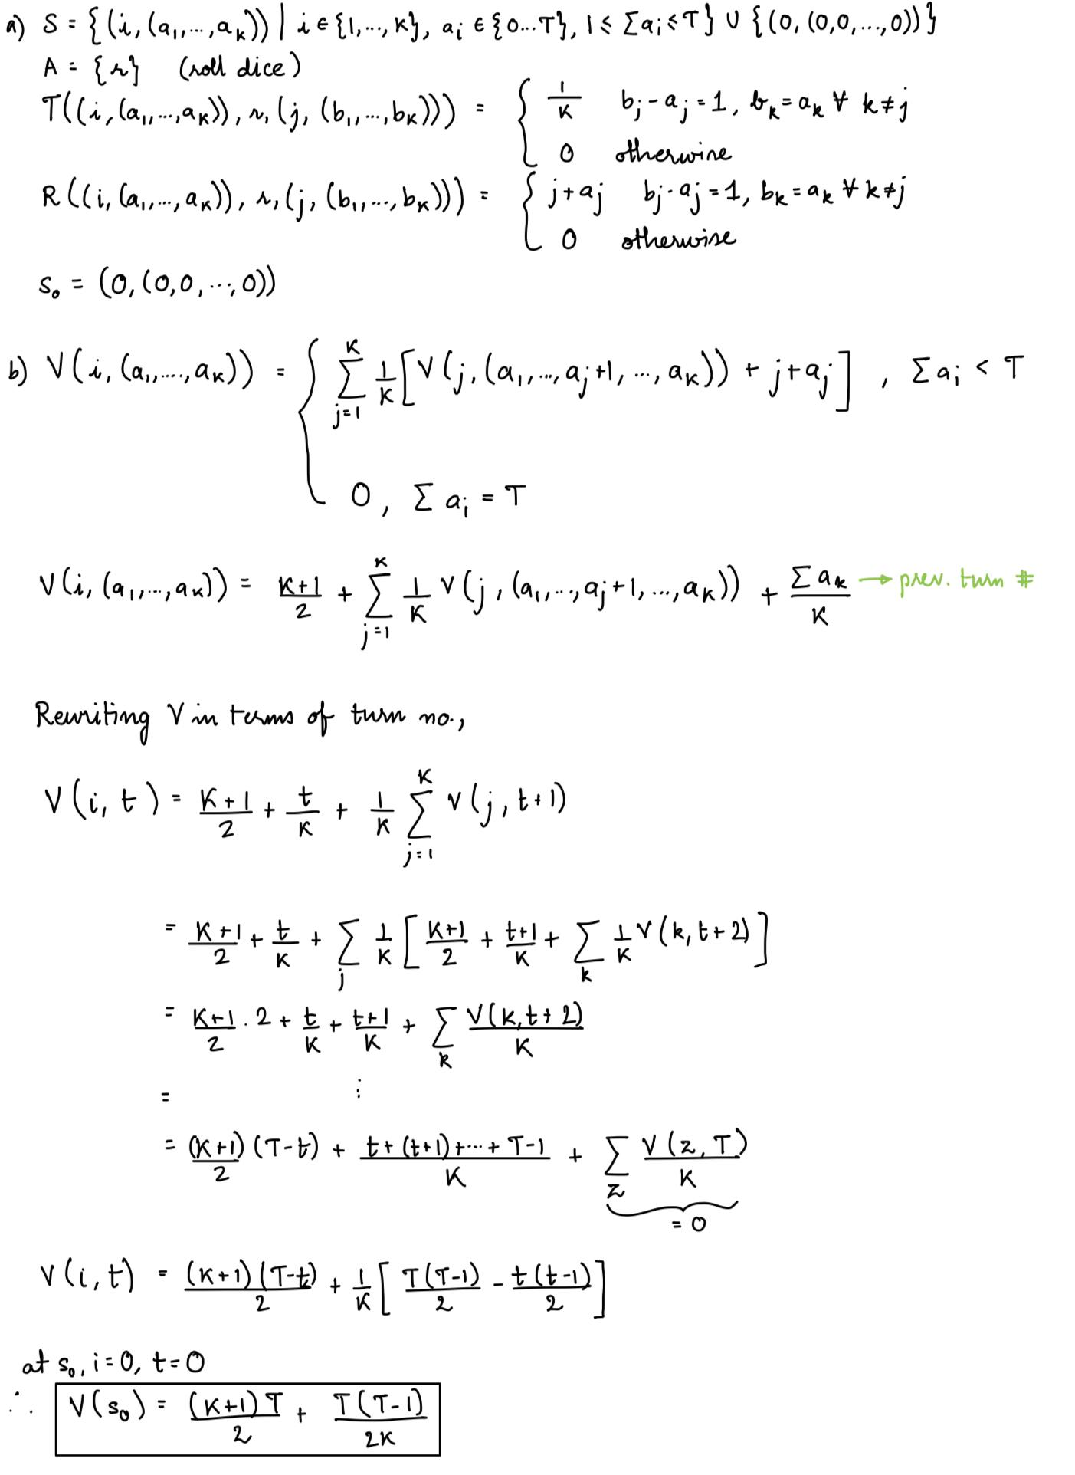

9) Supervised learning task is training is the process of next word prediction i.e, given the current set of words, what is the next word that is being predicted.

Reward Model which is based on the supervised model selects the response which aligns with the human preference with state space being the conversation history and action being the next word predicted.

1 point - defining the supervised task ie next word prediction or next response prediction

1 point - creating the dataset based on conversations between two users or web text

1 point - defining the state space and actions where state space is the question or conversation history and action is the next set of tokens.

1 point - defining how reward is obtained (based on choosing the response with highest human preference)

4.

Solution 1. Incorporates the Justification in class.

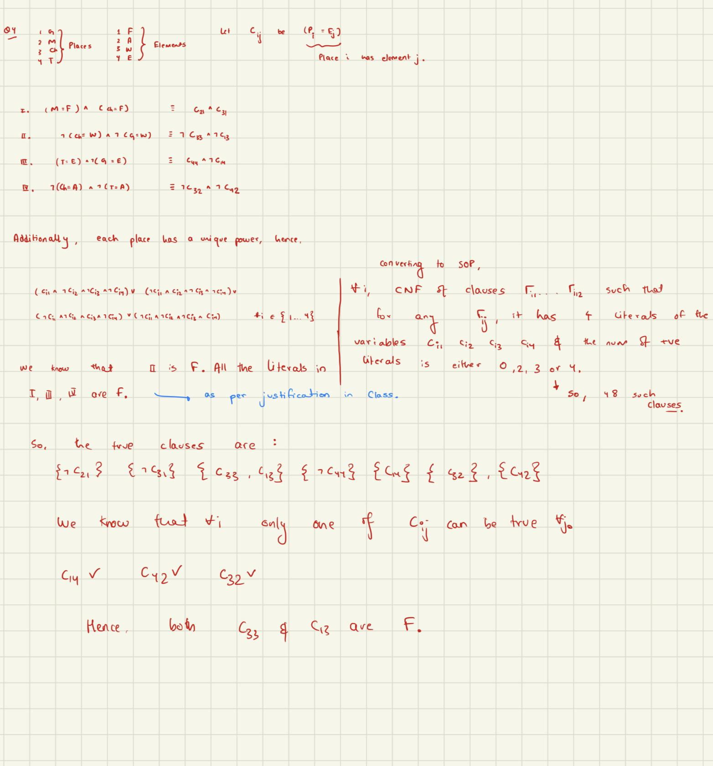

Solution 2. Ignores the justification in class.

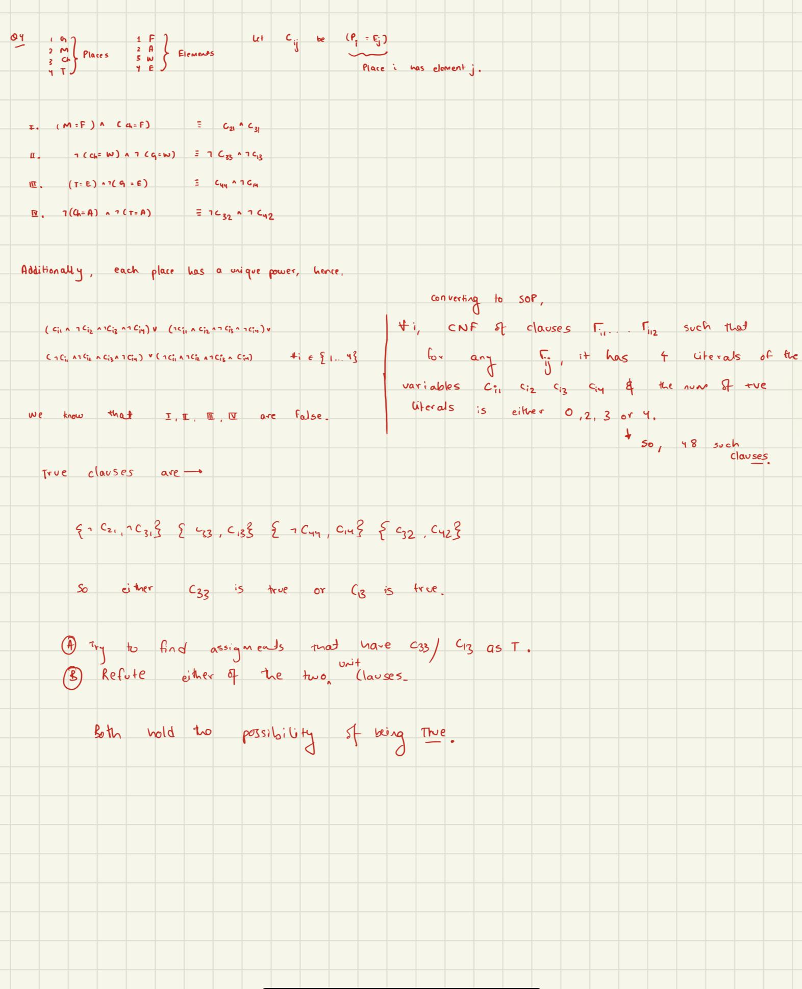

**Final Rubric**

Rubric:

* Defining symbols for 4 places and 4 powers – 2 marks.
* Converting each statement into negated (because they are lies) logical expressions – 7 marks. (1 for imam, 2 each for others) //whether on original interpretation or updated or mixed. Logical expressions need not be clauses.
  + -3 if negations is not done
  + -1 for every incorrect or missed logical expression
* 2 marks for conversion of uniqueness into logical expressions.
  + -1 if uniqueness is in words
* 5 marks for inference – can use resolution, forward checking or modus ponens. But, using basic logic in words is not enough.
  + -4 if inference is mostly incorrect or loosely mentioned in words
  + -1 Solution was unsat, but student didn’t consider all logical propositions
  + -2 Some Flaws in inference
* 1 mark for final answer. (could be that “given KB is not satisfiable, or the right answer – depending upon interpretations)

Q5.a)

**State :** A state will represent ***all***the possible planets where the rebels can be at the current step. So mathematically, the states will be subsets of the Power Set of .

**Action :** An action represents warping to a particular star. So

**Transition Function :** After performing the action, at the next timestep, rebels can be at any star which is a neighbour of the current star apart from the planet where we are at (as we would have captured them if it were the case)

Formally :

3 marks for formal representation as shown above or in any other equivalent form

**Goal State :** If the set is empty

**Start State :**

For above solution :

* 3 points for correct state representation
* 1 point for correct action
* 3 points for correct transition function
* 1 points for correct goal state
* 1 point for correct start state
* 3 points for drawing the correct search tree

5. b)

**Heuristic 1 (3 points)** : The number of planets where the rebels are at a given time.

Formally (Number of planets

**Heuristic 2 (1.5 points)** : 0.5 marks deducted only mentioned h(s) = 1

**Heuristic 3 (1 points) :**

**(0.5 points) :** Some other heuristic with correct idea correct but not admissible

5. c) An optimal solution with 5 actions

Check the stars in the following order -

* {1,3,5,7} a = 2
* {4,6} a = 3
* {5,7} a = 4
* {6} a = 3
* {7} a = 6
* {}

**(3 points) :**

First action at t=0:   
 3 -> e1 -> 3 -> e2 -> 3 -> e3 (e1,e2,e3 all different)

First action at t=1:  
 e1 -> 3 -> e2 -> 3 -> e3 (e1,e2,e3 all different)

Or any other optimal plan

**(2 points):**

Solution as above but did not mention that e1,e2,e3 have to be all different  
 Eg - (2,3,4,3,2) does not reach the goal state

**(2 points) :**

Any other plan which reaches the goal state but is not optimal

**(1 point) :**

Partially correct plan

5.d) An optimal solution with 10 actions

* We check the planets in the order as in part c
* If we manage to capture then we are done
* Otherwise the rebels must have started in an even planet, so after 5 time units, they must be in an odd planet
* So we check the planets the same order again

**(3 points)** : Optimal plan as shown above

**(2 points) :** Idea correct but plan is not optimal

**(1 point) :** Idea correct but plan not specified / plan does not reach the goal state

Other solutions might get partial/full credit.

6. (a) No

1. Yes
2. P(I1 = L, F1 = Y) = 0.8*0.35 = 0.28

P(I1 = M, F1 = Y) = 0.1*0.4 = 0.04

P(I1 = H, F1 = Y) = 0.1*0.8 = 0.08

P(I1 = L | F1 = Y) = 0.28/0.4 = 0.7

P(I1 = M | F1 = Y) = 0.04/0.4 = 0.1

P(I1 = H | F1 = Y) = 0.08/0.4 = 0.2

2 marks for correct expressions

1 mark for calculation

1. Paracetamol at t=1 (V1 = F):

P(I2 = L, F1 = Y, V1 = F) = 0.1*0.8*0.05+0.1*0.4*0.05+0.8*0.35*0.9 = 0.258 - 0.5 mark

P(I2 = M, F1 = Y, V1 = F) = 0.1*0.8*0.05+0.1*0.4*0.9+0.8*0.35*0.05 = 0.054 - 0.5 mark

P(I2 = H, F1 = Y, V1 = F) = 0.1*0.8*0.9+0.1*0.4*0.05+0.8*0.35*0.05 = 0.088 - 0.5 mark

P(I2 = L | F1 = Y, V1 = F) = 0.258/0.4 = 0.645 - 0.5 mark

P(I2 = M | F1 = Y, V1 = F) = 0.054/0.4 = 0.135 - 0.5 mark

P(I2 = H | F1 = Y, V1 = F) = 0.088/0.4 = 0.22 - 0.5 mark

Here is an alternate solution:

P(I2 = | F1 = Y) = \sum_{i} P(I2 = L | {I1 =i, F1 = Y, V1 = F)P(I1 =i | F1 = Y)

= \sum_{i} P(I2 = L | {I1 =i, V1 = F)P(I1 =i | F1 = Y)

//note second prob already computed in part (c)

= 0.9*0.7 + 0.05*0.1 + 0.05*0.2

= 0.63 + 0.005 + 0.01 = 0.645 (and so on).

Note that by intelligently using calculation of part (c), part (d) becomes very easy, and does not even require normalization!

Rubric: 3 marks for writing the correct formulas for computation, 3 marks for calculation (1.5 each)

Antiviral at t=1 (V1 = T):

P(I2 = L, F1 = Y, V1 = T) = 0.1*0.8*0.1+0.1*0.4*0.7+0.8*0.35*0.8 = 0.26 - 0.5 mark

P(I2 = M, F1 = Y, V1 = T) = 0.1*0.8*0.5+0.1*0.4*0.2+0.8*0.35*0.2 = 0.104 - 0.5 mark

P(I2 = H, F1 = Y, V1 = T) = 0.1*0.8*0.4+0.1*0.4*0.1+0.8*0.35*0 = 0.036 - 0.5 mark

P(I2 = L | F1 = Y, V1 = T) = 0.26/0.4 = 0.65 - 0.5 mark

P(I2 = M | F1 = Y, V1 = T) = 0.104/0.4 = 0.26 - 0.5 mark

P(I2 = H | F1 = Y, V1 = T) = 0.036/0.4 = 0.09 - 0.5 mark

1. Expected Reward for Paracetamol (V1 = F) = -10 + 0.645*500+0.135*50+0 = 319.25

Expected Reward for Anti-Viral (V1 = T) = -30 + 0.65*500+0.26*50+0 = 308

Ans: Paracetamol

Grading scheme: 1 mark for right equation, 1 mark for using correct probabilities from previous step, 1 mark for calculation, 1 mark for correct final action

1. P (I2 = L, F1 = Y) =

P(I1 = L)*P(F1 = Y | I1= L) *(P(B1 = L | I1 = L) * P(I2 = L| I1 = L, V1 = F) + P(B1 = NL | I1 = L) * P(I2 = L| I1 = L, V1 = T)) +

P(I1 = M)*P(F1 = Y | I1= M) * (P(B1 = L | I1 = M) * P(I2 = L| I1 = M, V1 = F) + P(B1 = NL | I1 = M) * P(I2 = L| I1 = M, V1 = T)) +

P(I1 = H)*P(F1 = Y | I1= H) * (P(B1 = L | I1 = H) * P(I2 = L| I1 = H, V1 = F) + P(B1 = NL | I1 = H) * P(I2 = L| I1 = H, V1 = T))

=0.8*0.35*(0.8*0.9+0.2*0.8) +

0.1*0.4*(0.2*0.05+0.8*0.7) +

0.1*0.8*(0.2*0.05+0.8*0.1)

= 0.2764 - 2 marks

Similarly,

P (I2 = M, F1 = Y) = 0.8*0.35*(0.8*0.05+0.2*0.2) +

0.1*0.4*(0.2*0.9+0.8*0.2) +

0.1*0.8*(0.2*0.05+0.8*0.5)

= 0.0688 - 2 marks

P (I2 = H, F1 = Y) = 0.8*0.35*(0.8*0.05 + 0.2*0) +

0.1*0.4*(0.2*0.05+0.8*0.1) +

0.1*0.8*(0.2*0.9+0.8*0.4)

= 0.0548 - 2 marks

P (I2 = L | F1 = Y) = 0.2764/0.4 = 0.691 - 1 mark

P (I2 = M | F1 = Y) = 0.0688/0.4 = 0.172 - 1 mark

P (I2 = H | F1 = Y) = 0.0548/0.4 = 0.137 - 1 mark

Expected positive reward = 0.691*500+0.172*50 = 354.1

P (V1 = False | F1 = Y) = P(T1 = L | F1 = Y) = 0.62 - 0.5 mark

P (V1 = True | F1 = Y) = P(T1 = NL | F1 = Y) = 0.38 - 0.5 mark

Expected negative reward = 0.62*(-10) + 0.38*(-30) = -17.6

Total reward = 354.1 - 17.6 = 336.5 - 1 mark

Gap = 336.5 - 319.25 = **17.25** - 1 mark

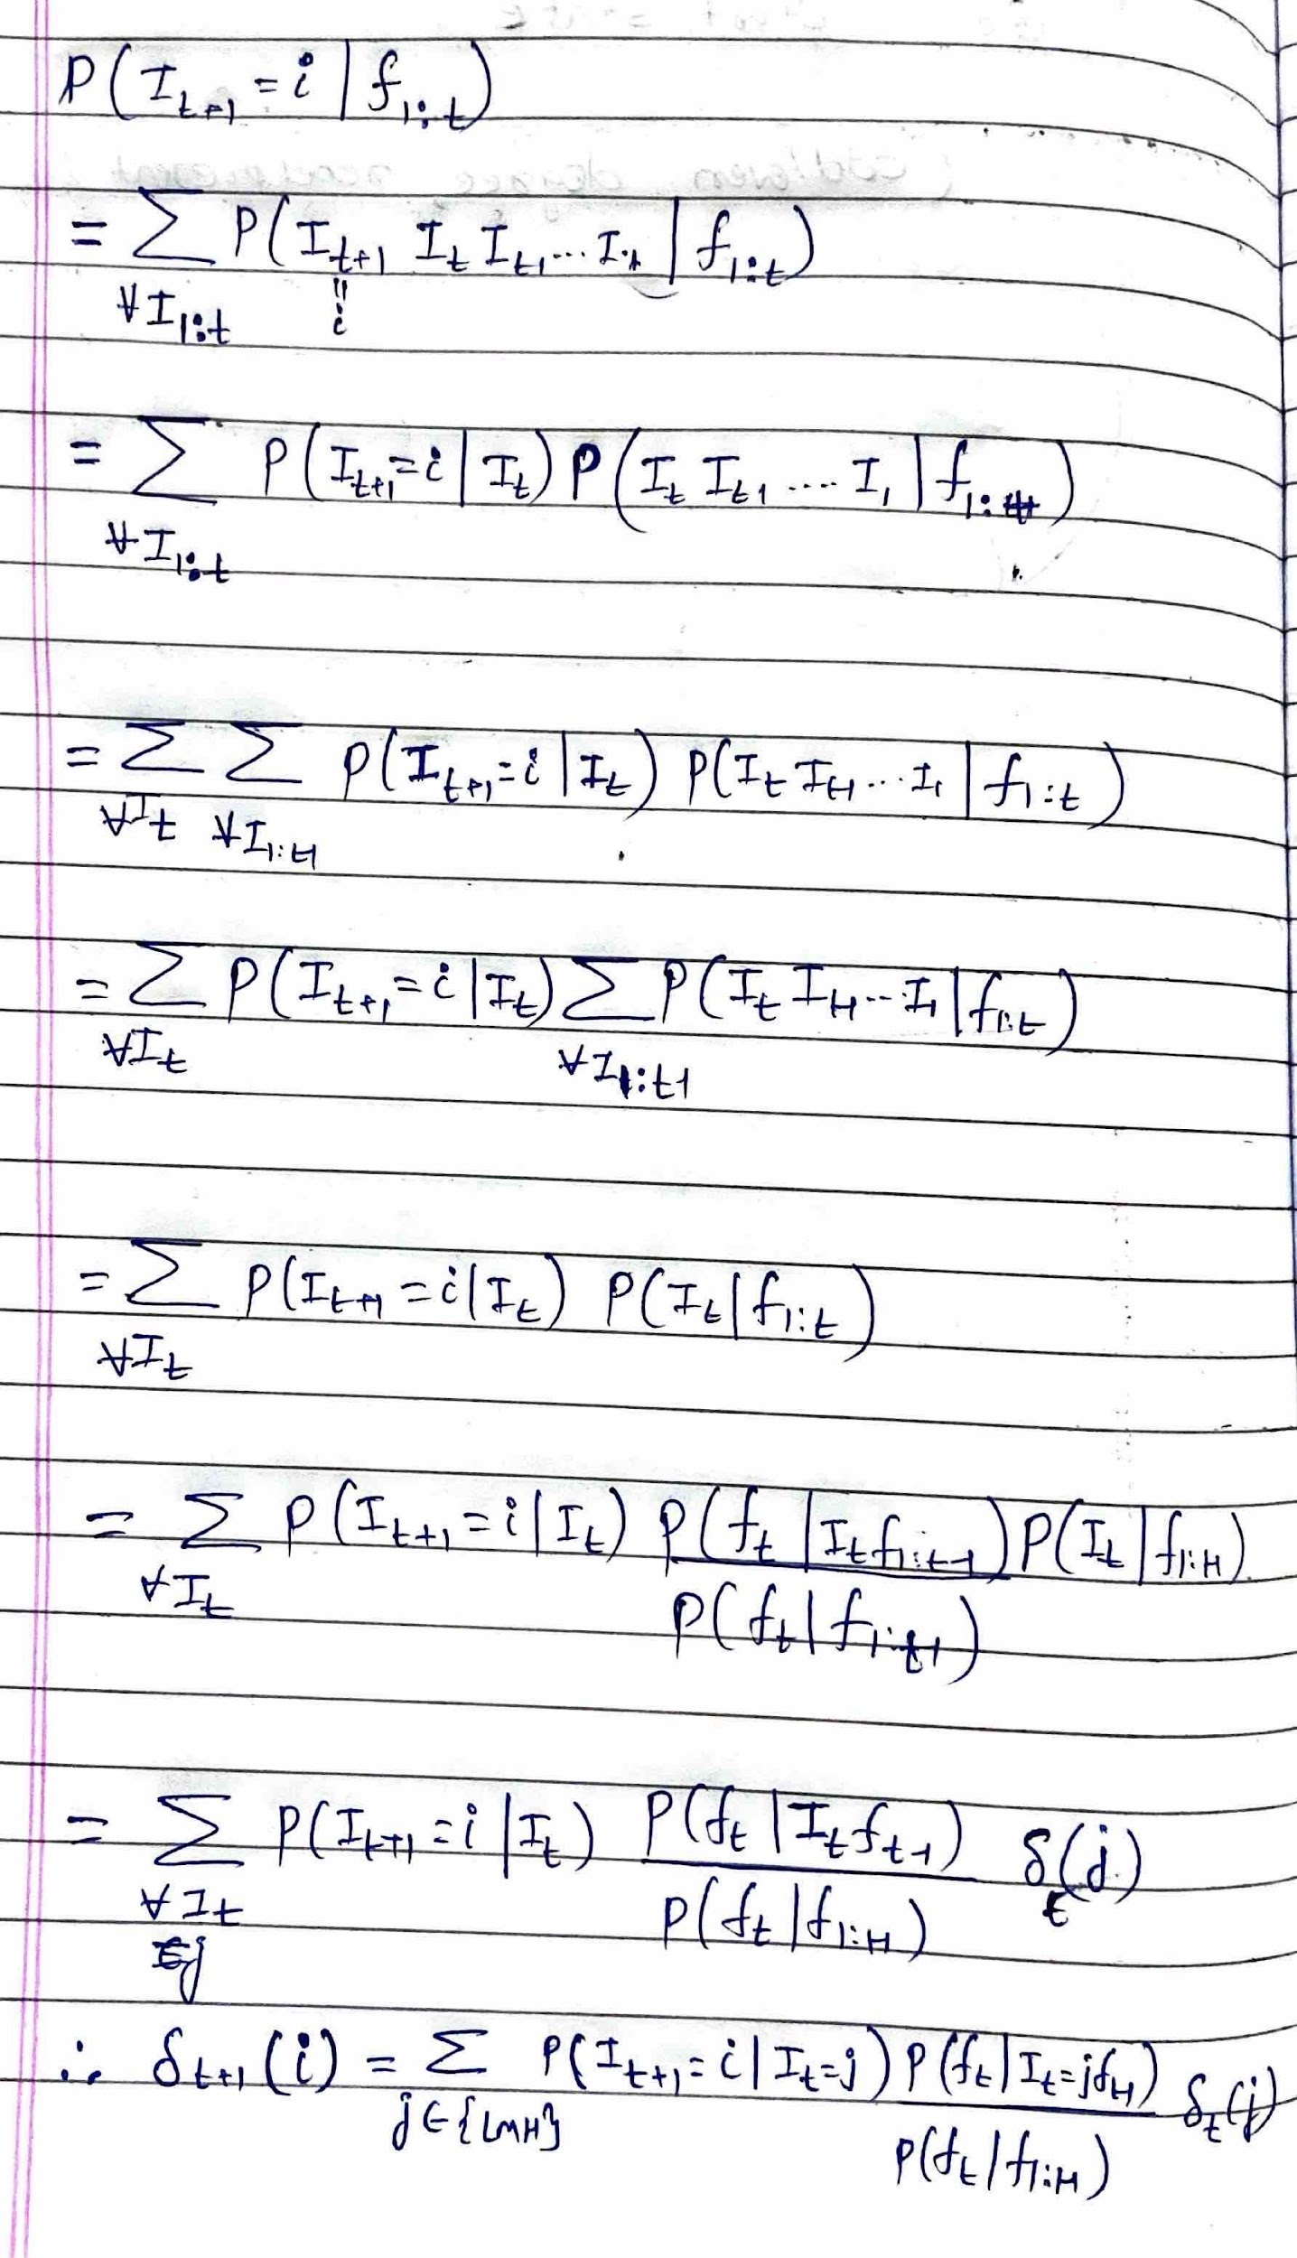

1. Solution uses Marginalization, D-seperation and Conditional Probability respectively. Graded subjectively.

7) Total marks = 9 (Undivided)

Marks distribution: (a) -> 2, (b) -> 3, (c) -> 4.

a)2: Correct equation.

0: otherwise.

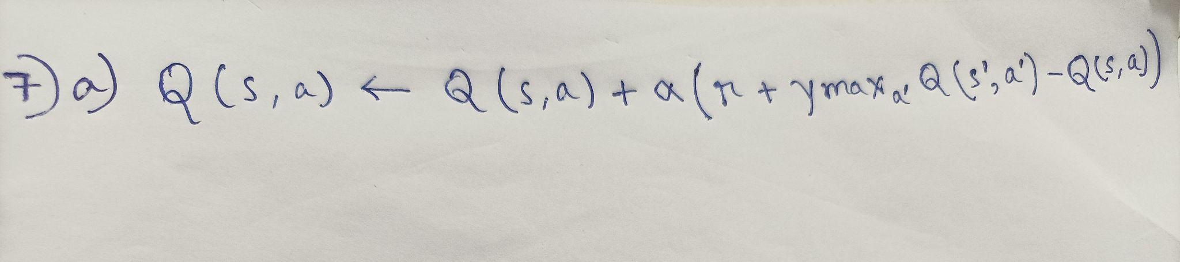

b) 3: Correct answer.

0: Otherwise.

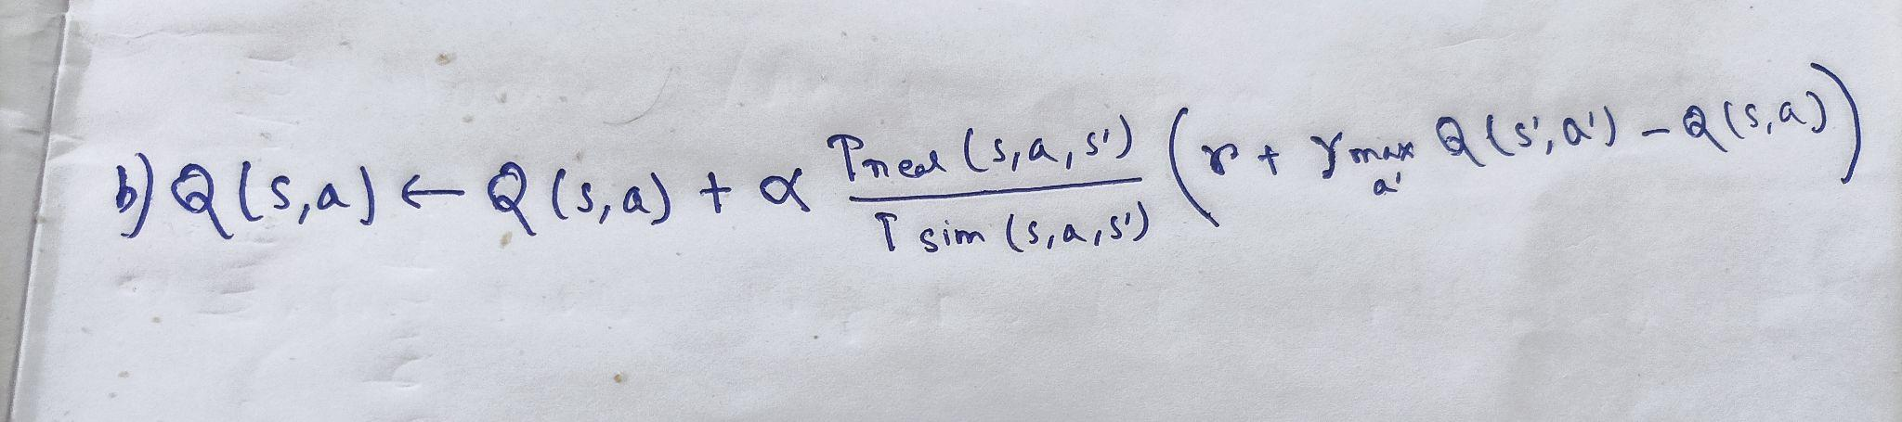

c) 4: correct for all 4 parameters

2: Minor mistake or correct approach.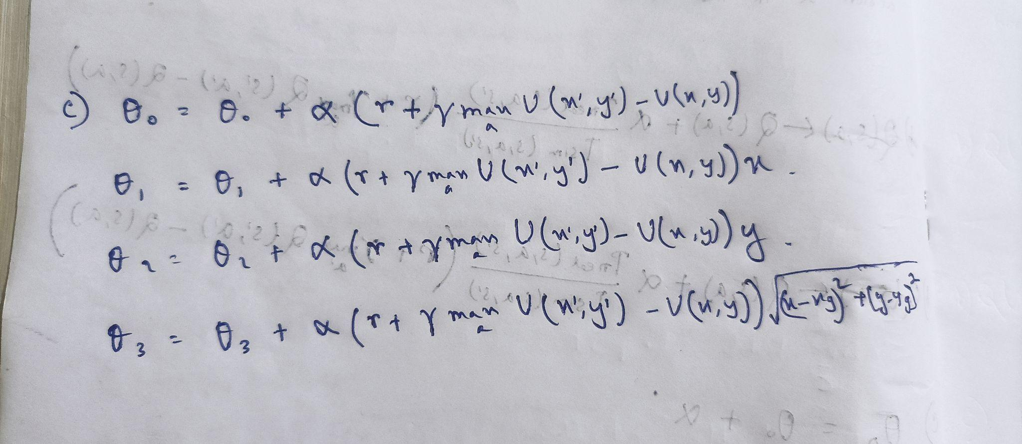

0: others.

8. a)

* Negative costs introduce the possibility of infinite paths with decreasing costs. To traverse all these paths, the algorithm needs to explore the whole search space.
* An edge with high negative value that leads to the most optimal path can be left unexplored if all the nodes of the search space are not explored.

The edge to the last state may have extremely high negative cost making the whole path optimal.

**Rubric: subjective; if the above key ideas are expressed - 2 marks**

**If answer is around the key idea - 1 mark**

b)No, A* stops when the first goal is removed from the fringe. Imagine a path from start state to optimal goal that goes through another intermediate goal. At some point, the intermediate goal will be removed from the fringe, and A* will terminate.

**Rubric - No, with this answer will get 2 marks**

**No, with any other explanation will get 1 mark**

Yes, the heuristic guides the search by providing an optimistic estimate of the remaining cost, helping A* prioritise paths that seem promising. The negative edge values may influence the actual path cost, but the heuristic ensures that A* makes informed decisions leading to an optimal solution.

**Rubric: this answer is incorrect, but will get 1 mark**

**Yes, with no/ any other explanation - 1 mark**

The real answer is actually technical! A* stops when the first goal is removed from the fringe. Imagine a path from start state to optimal goal that goes through another intermediate goal. At some point, the intermediate goal will be removed from the fringe, and A* will terminate. Hence the real answer is NO and this reasoning should give 2 marks.

**Rubric: Yes with explanation you give – 1**

**Yes, with no/any other explanation - 0 marks**

c) (i) Depth first search :

(c-c*) <= (Max cost)d - m*r / (c-c*) <=c+m*r / unbounded/infinite - **2 marks**

(c-c*) <= (m-d).r  **- 1 mark**

(ii) Breadth first search :

same as above

(iii) Uniform cost search: (m-1).r  **- 2 mark**

**Any other answer will get no marks**

10- Formalising the problem and writing propositional literals for the statements given. Subjective, depends on the progress made. 2.5 marks for each statement.

7 marks- Tried resolving the set of True clauses. Either by solution 1 or solution 2. If got stuck in between due to either both being true or none being true, full marks.